**User Guide**

**C2 UI Checks Automation**

### **Prerequisites**

Before you begin, ensure you have the following installed on your system:

1. **Python** (version 3.6 or later)
2. **pip** (Python package installer)
3. **GRL_C2_BROWSER_APP**

### **Step 1: Install Selenium WebDriver**

Selenium WebDriver is a powerful tool for controlling web browsers through programs and performing browser automation.

**Installation:** Open your terminal or command prompt and run the following command:

>> pip install selenium

**Verification:** To verify the installation, you can run a simple script to check if Selenium is working:

**1.Create a Python Script:**

Open your preferred text editor or IDE (such as VS Code, PyCharm, or any text editor).

**2.Write the Script:**

## from selenium import webdriver

## driver = webdriver.Chrome

## driver.get("https://www.google.com")

## print("Page title:", driver.title)

## driver.quit()

## print("Selenium is successfully imported and working.")

**3.Save and Run the Script:**

* Save the script with a .py extension, for example, selenium_test.py.
* Now run selenium_test.py.
* If Selenium is imported correctly and the WebDriver launches Chrome and accesses Google, you should see output similar to:

Page title: Google

Selenium is successfully imported and working.

## Make sure you have the appropriate WebDriver for your browser in the directory:

## *“UI Checks Automation\Resources\chromedriver-win64\chromedriver.exe”.*

## For example, if you're using Chrome, download the ChromeDriver from [here](https://developer.chrome.com/docs/chromedriver/downloads).

**Step 2: Install PyYAML**

Open your terminal or command prompt and run the following command:

## >> pip install PyYAML

## PyYAML is a YAML parser and emitter for Python.

**Step 3: Install Logging**

Open your terminal or command prompt and run the following command:

## >>pip install logging

## Logging is a module for Python that provides a flexible framework for emitting log messages from Python programs.

## Step 4: Changing the mode

In the directory *“UI Checks Automation\json\setting.json”*, update the following fields in the YAML File:

1. **Mode**: If the Tester is "C2", set the mode to "C2". If the Tester is "C2 EPR", set the mode to "C2EPR".
2. **DynamicIP**: Update the IP address as needed. (ex. 192.168.5.17)
3. **Static_dynamic**: Modify this field based on how the tester is connected to the computer. (ex. Static or Dynamic).

## 

**Step 5: Execute the Program**

Run the ui_check_setup.py script in Visual Studio Code and wait for 2-3 minutes for the execution to complete.

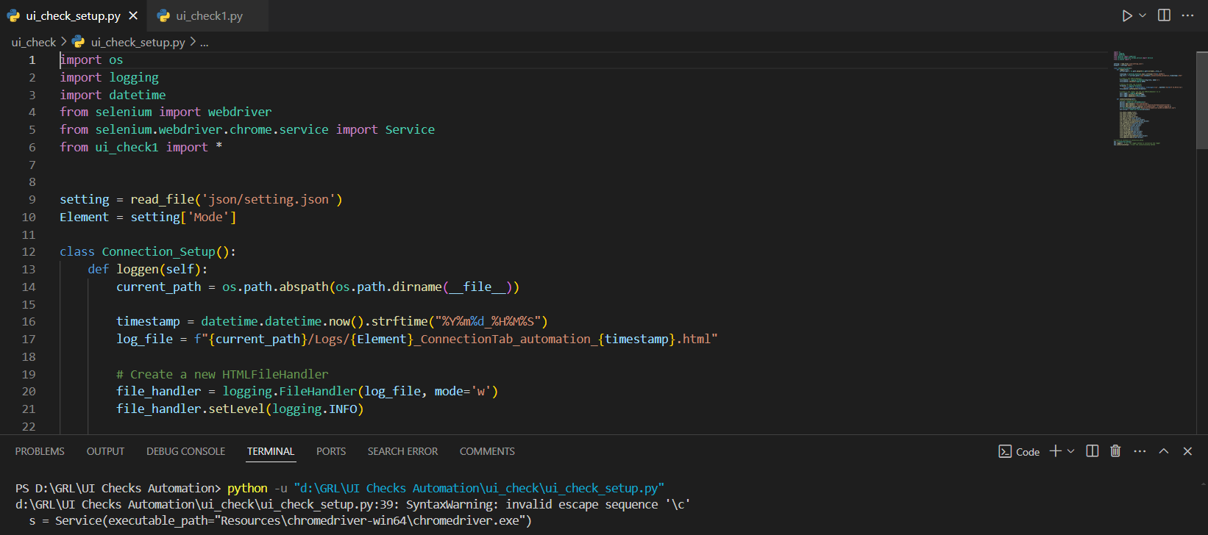

After execution the logs will be stored in the directory.

*“UI Checks Automation \ui_check\Logs”*.

## 

## Test Cases:

## TC-1: Check whether the ReadMe File is present in the specific directory.

## TC-2: Check whether the Release Notes File is present in the specific directory.

## TC-3: Check whether the Eload File is present in the specific directory.

## TC-4: Check whether all the Firmware Files are present in the specific directory.

## TC-5: Check whether the Browser opens

## TC-6: Fetch the Browser Tab Title

## 

## TC-7: Check whether that the Scan Network Button is present and whether it's clickable or not.

## 

## TC-8: Check whether that after clicking the Scan network button, the loading icon is visible, and the connect button should be disabled, and vice versa

## 

## TC-9: Please ensure that the device details keys are correctly present on the connection setup page

## 

## TC-10: Verify the address Text

## 

## TC-11: Clicking the scan network, verify default IP is present in the C2 IP Address input box and connect

## 

## TC-12: Verify Connection with Dynamic IP and Verify the Tester Status

## 

## TC-13: Pass Invalid IP Address and Verify the Tester Status

## 

## TC-14: Pass Unreachable IP Address and Verify the Tester Status

## 

## TC-15: Verify the Setup Diagram

## 

## TC-16: Please ensure that the software and hardware details keys are correctly present on the connection setup page

## 

## TC-17: Check that the Firmware Update Button is present and whether it's clickable or not.

## 

## TC-18: Check that the Firmware Update Button is clicked and the Tester is Restarted

## 